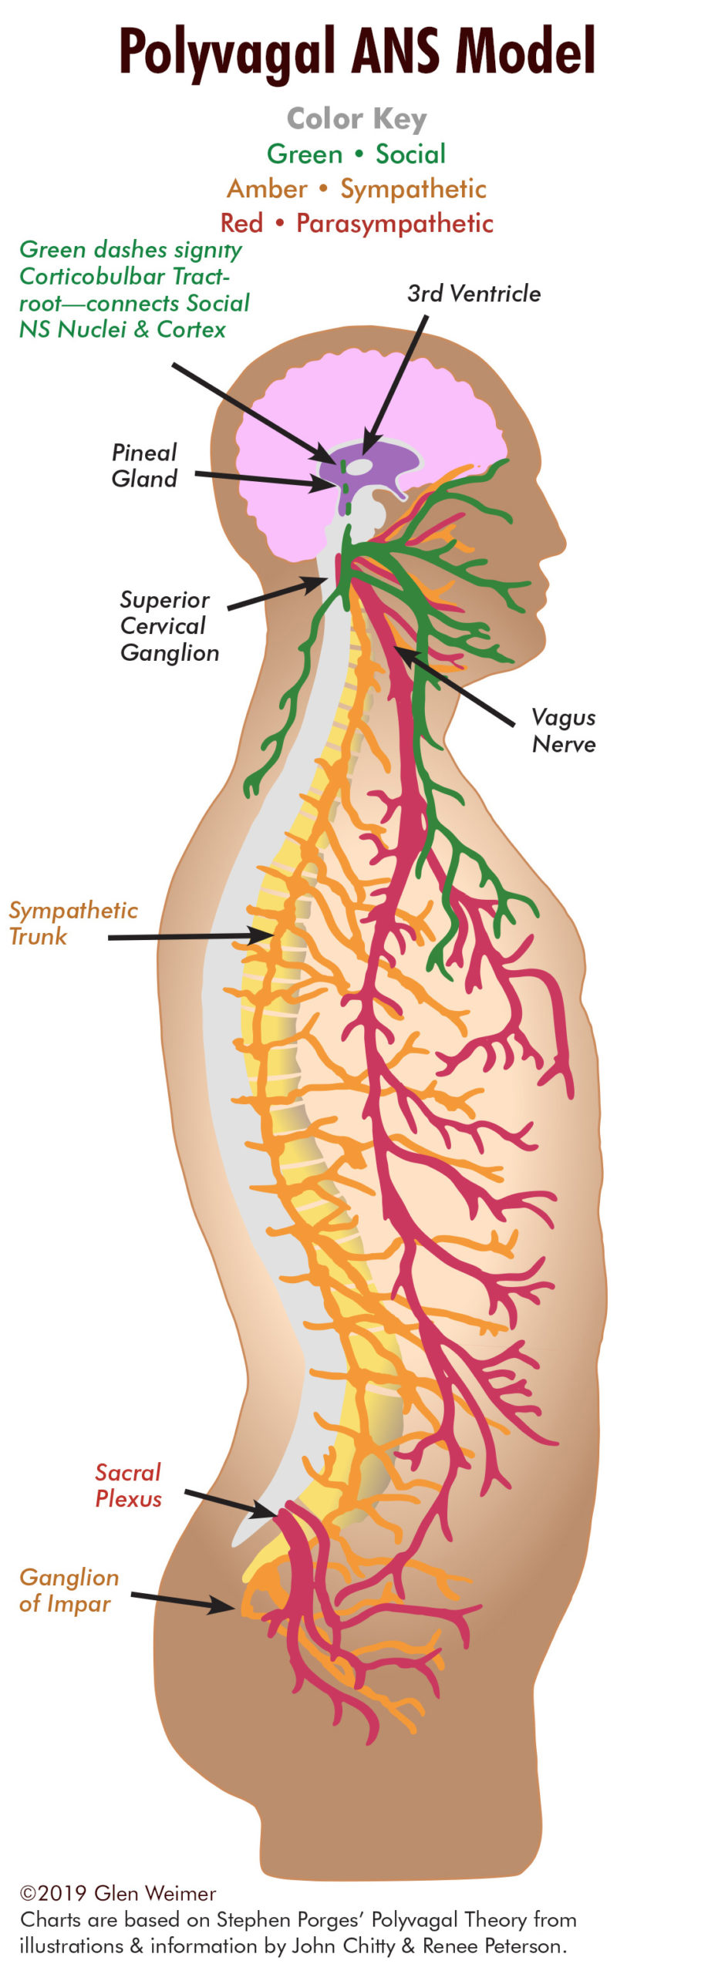
Polyvagal Theory focuses on how function and structure changed in the vertebrate autonomic nervous system during evolution. The theory is named after the Vagus, a major cranial nerve that regulates bodily state.

The Vagus or 10th cranial nerve establishes a direct line of communication between the brain and body. It can be said to be the master switch for our Autonomic Nervous System (ANS).

Dr. Stephen Porges described two distinct vagal pathways: Ventral Vagal (green) which controls facial muscles, voice, hearing, heart and lungs (generally front of the body above the diaphragm); and Dorsal Vagal (red) which controls brain stem, digestion and reproduction (generally below the diaphragm governing core survival functions).

The third pathway is the Sympathetic Nervous System (orange) which comes off of a trunk or chain of nerves running alongside the spine at the level of the chest and low back (controlling mobilization of the torso, arms and legs to fight and flee). Each system up-regulates certain body functions and down-regulates opposing ones.

The ventral vagal (green) pathway regulates our bodily state, controlling facial gestures, listening (i.e., middle ear muscles), and vocal communication, and functions as what is collectively referred to as the Social Engagement System (SES). Because the SES is an integrated system, interventions influencing one component of this system (e.g., middle ear muscles) may impact on the other components.

The SES dictates how we operate within our social and physical environment. It describes how our perceptive faculties impact on our ability to relax, coordinate and communicate with others around us when our environment and company feels safe and unthreatening.

The vagus nerve is involved in how we perceive, react to and recover from stress. Eye contact, smiling, and tone of voice are pivotal for good relationships and provide vital clues to our nervous system.
Under social conditions where we feel confident, our heart rate and breathing slows down, our blood pressure drops and our stress response switches off. Our bodies enter a state of physical calm. We feel safe enough to move closer to another person, making social engagement, and/or intimacy, possible.
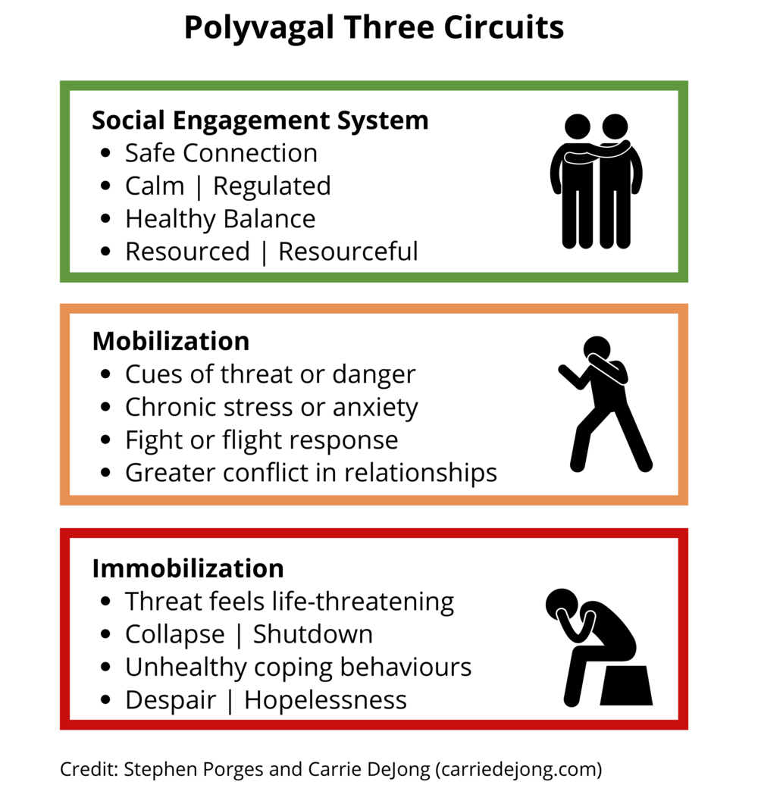
In this way, social engagement both depends on and enhances our sense of safety, creating a positive feedback loop which leads to further calming. However, whether we feel safe or not is not within our conscious control, and if the body detects that we are in "danger" (owing to something we hear, see or otherwise sense), it switches to the sympathetic fight/flight response.

Some of the motor components of the face and throat are under voluntary control and some are not. That is why some behaviours, like a smile, can be only partly simulated. The absence of the involuntary movement (for instance in a 'forced' smile) has always been detectable by discerning people (and the giveaway is usually in the eyes), and a perceived discrepancy such as this can be enough to give us an uneasy feeling, impacting on our ability to stay socially engaged with that person.

The self-regulation goal for the autonomic system is not any specific point of arousal along the parasympathetic-sympathetic continuum. Rather the goal is flexibility, range, and versatility. Some situations require high parasympathetic tone (digesting), some high sympathetic tone (chopping wood), and some both simultaneously (play, sex). At best, the autonomic system interacts with the environment for optimal adaptation to present circumstances.

